DOCUMENT 23 — Safety, Guardrails & Child Protection Spec
Visionary Internal · v1.0 · Inline guards — nothing unsafe or wrong ever renders

A child product's safety layer is its licence to operate. Every guard runs inline in
the request path (AIRA DDR-04), so an unsafe or unverified response cannot reach a screen.

1. Input guards (L1)
- Prompt-injection defense: role/system-override patterns rejected; tool-call allowlist only.
- Crisis keywords: HARD-STOP normal teaching; safe response + helpline config; event logged,
raw text never used for training.
- Centralized age/role eligibility (journeyEligibility): a minor can never receive a
professional/adult journey fallback — entry filtering AND response suggestions (QA-H02).

2. Output guards (L4)
- Constitutional AI filter: block adult content, political opinion, self-harm material.
- Hallucination guard: NLI claim extraction → Qdrant NCERT-corpus check; factual claim
confidence <0.70 → replace with retrieved verified statement + log for human review;
never a hallucinated formula, date or scientific fact; target accuracy ≥99.5%.
- Arithmetic only via calculate_math tool — the LLM never computes numbers.

3. Child-protection rules
- No paywall inside child teaching; no invented upgrade benefit (Doc 12/18 rule).
- 3 failed verification attempts → flag human teacher, move on gently; no infinite loop.
- Support surface offers report/block flows; never fabricated human contact.
- Honest capability states: no live-AGI, always-listening or cloud-sync claims (D-008).

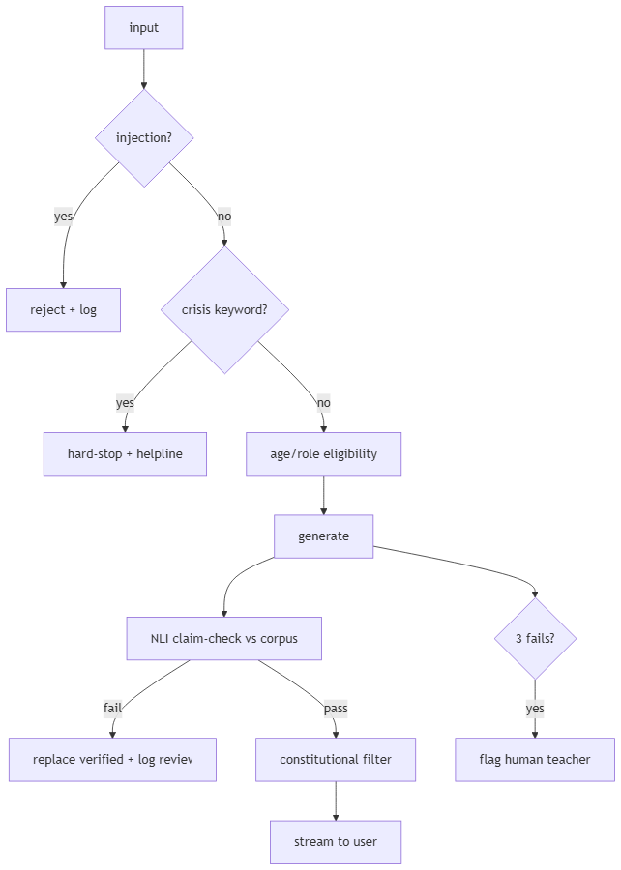

OKF
KF1 crisis hard-stop 100% on keyword set · KF2 hallucination <0.5% on NCERT benchmark ·
KF3 minor never served adult/professional journey · KF4 zero paywalls in child teaching
path · KF5 every block/reject/flag action logged and auditable.

